PROGRAMME 1

AIM:Write a program that prompts the user to enter his first name and last name and then displays a message “Greetings!!! First name Last name”.

greeting.py

firstname=input("Enter your firstname:")
lastname=input("Enter your lastnmae:")
print(f"Greeting!!!{firstname}{lastname}")

OUTPUT
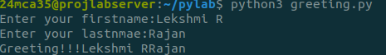

PROGRAMME 2
AIM:Write a program to demonstrate different number data types in python
data.py

a=3
b=5.5
c=3j
print("type of a is:",type(a))
print("type of b is:",type(b))
print("type of c is:",type(c))

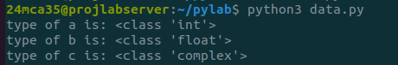
OUTPUT

PROGRAMME 3
AIM:Write a program to calculate the area of a circle by reading inputs from the user.

area.py

pi=3.14
r=int(input("Enter radius of the circle r:"))
area=pi*r*r
print(f"Area of the circle is {area}")

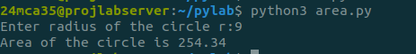
OUTPUT

PROGRAMME 4
AIM:Write a program to calculate the salary of an employee given his basic pay (to be entered by the user) . HRA = 10 percent of the basic pay, TA = 5 percent of the basic pay.
salary.py

Basic_Salary=int(input("Enter the basic salary of the employee:"))
HRA=10*Basic_Salary/100
TA=5*Basic_Salary/100
Total_Salary=Basic_Salary+HRA+TA
print("Total Salary is:",Total_Salary)

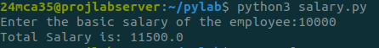
OUTPUT

PROGRAMME 5
AIM:Write a Python program to perform arithmetic operations on two integer numbers.

arithmetic operation.py

a=int(input("Enter first number:"))
b=int(input("Enter second number:"))
sum=a+b
difference=a-b
product=a*b
division=a/b
modulus=a%b
print(f"The sum is {sum}\n The difference is {difference}\n The product is {product}\n The division is {division}\n The modulus is {modulus}")

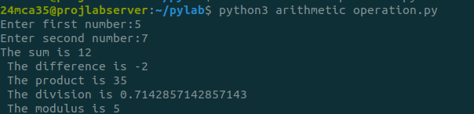

OUTPUT

PROGRAMME 6
AIM:Write a Python program to get a string which is n (non-negative integer) copies of a given string.
string.py

a=input("Enter the string")
n=int(input("enter no.of.times"))
copies=a*n
print(f"The copies of string is {copies}")

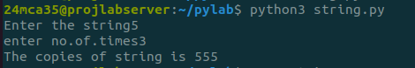
OUTPUT

PROGRAMME 7
AIM:Find biggest of 3 numbers entered.
largest.py

a=int(input("enter first number"))
b=int(input("enter second number"))
c=int(input("enter third number"))
if a>b and a>c:
print(f"{a}is greatest")
elif b>c and b>a:
print(f"{b} is greatest")
else:
print(f"{c}is greatest")

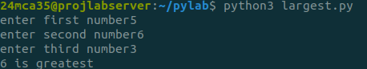

OUTPUT

PROGRAMME 8
AIM:Program to determine whether a year is a leap year or not

leapyear.py

year=int(input("enter year"))
if (year%4==0) and (year%100!=0 or year%400==0):
print("leap year")
else:
print("not a leap year")

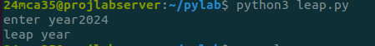
OUTPUT

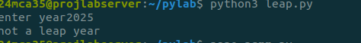

PROGRAMME 9
AIM:Write a Python program to determine the rate of entry-ticket in a trade fair based on age as follows:

trade.py

age=int(input("enter age:"))
if age<10:
print("ticket rate is 7")
elif 10<=age<60:
print("ticket rate is 10")
elif age>=60:
print("ticket rate is 5")
else:
print("enter proper age")

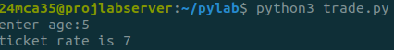
OUTPUT

PROGRAMME 10
AIM:Program to accept an integer n and compute n+nn+nnn.

integer.py

n=int(input("enter your n"))
result=n+(n*10+n)+(n*100+n*10+n)
print(f"result:{n}+{n}{n}+{n}{n}{n}={result}")

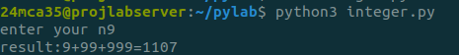
OUTPUT

PROGRAMME 11

AIM:Write a Python program to solve a quadratic equation.
eqn.py
nano 6.2 eqn.py
import math
print("Quadratic equation ax^2+bx+c")
a=float(input("Enter a value for a:"))
b=float(input("Enter a value for b:"))
c=float(input("Enter a value for c:"))
num=(b*b)-(4*a*c)
if num==0:
print("Only one root is possible")
ans=(-b)/(2*a)
print(f"x1={ans}")
elif num>0:
sqrtvalue=math.sqrt(num)
ans1=(-b+sqrtvalue)/(2*a)
ans2=(-b-sqrtvalue)/(2*a)
print(f"x1={ans1}")
print(f"x2={ans2}")
else:
print("Complex number")
sqrtvalue=math.sqrt(abs(num))/(2*a)
real_part=-b/(2*a)
print(f"{real_part}+i{sqrtvalue}")
print(f"{real_part}-i{sqrtvalue}")

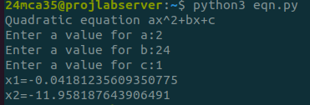
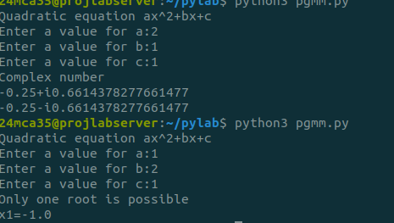
OUTPUT

